Modern Chinese Woodblock Prints

The history of Chinese Modern prints is intimately tied to social and political developments in 20th century China. On May 4, 1919, a protest against the provisional government’s feeble response to the treaty of Versailles and the Japanese occupation attracted left-leaning students and artists to the city of Beijing. Amongst the protestors, a cluster of artists and writers used the immediacy of the woodblock to mass-produce subversive and anti-Japanese political images and messages. Under the mentorship of Lu Xun (鲁迅, 1881-1936), one of China’s greatest Modern literary figures, they adopted the nianhua (年画, new year calendar prints) or xinnian huazhi (flowery new year calendar) as a vehicle for experimentation with wood block printing. The creative woodcut movement pioneered by Lu Xun sought to undermine the petit-riche ownership of the woodblock and re-contextualise art as the property of the masses. In order to reconcile the aims of the Creative Woodblock movement with the tastes of the rural populations Lu Xun advocated the adoption of familiar peasant pictorial devices in the production of a new art.

In 1931, Lu Xun engaged the Japanese artist and art teacher Uchiyama Kakichi to give classes in Japanese woodcutting and wood-engraving techniques. Many progressive artists including some from the Eighteen Society and the League of Leftwing Artist attended the class held in the Japanese Language School in Shanghai. And whilst the classes lasted just one week, from 17 to 22 August, they had a dramatic impact on the Creative Woodblock Movement, also known as the Modern Woodblock or New Woodblock movement. In Shanghai, the group continued to develop their practice through the observation of German Expressionist and Soviet prints from Lu Xun’s Library and personal collection, including works by Kathe Kollwitz, Frans Masereel and Nikolai Piskarev.

Two works by Li Qun, The Lu Xun College of Literature and Art at Yan’an (1938) and Lu Xun (1935), an example of the lingxiu xiang (a genre of leader’s portraiture adopted from Soviet practice) stand as a testimony, not only to the stature of Lu Xun, but also to the widespread movement of work influenced by European and Soviet artistic traditions. For Li Hua at least, the work of Kathe Kollwitz proved a great inspiration. Her series of sketches on The Peasants Revolt describe proud figures emerging from a predominantly black background that provides a clear visual allegory for the enlightenment and liberation of the Chinese peasantry emerging from a dark history of feudal oppression.
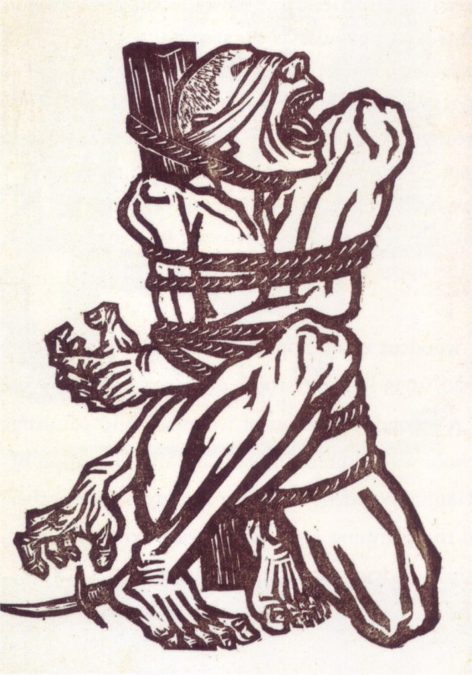
Li Hua, China, Roar!, 1936, woodcut print, image in the public domain.

By the late 1930’s the Creative Woodblock movement could be differentiated from the traditional woodblock practices in at least three ways. Firstly, representations of “common” people replaced the depiction of deities and prominent cultural figures, and images were injected with political content to replace the religious and superstitious. Secondly, European oil based printing inks were used instead of the traditional water based Chinese inks, which allowed for a new range of formal expressive effects. Also, the implementation of Japanese technique brought with it a use of different knives and rubbing pads and their relevant methods and effects. Thirdly, in the new movement, the artist was the sole producer, designing, cutting and printing the block instead of the division of labour that existed previously.

Whilst Mao largely agreed with Lu Xun’s methodology he encouraged artists to produce art with a less expressionistic and more positivist vein that reinforced the aims of the revolution. To this effect, posters, calendar and New Year prints depicting the dissemination of knowledge on the topics of hygiene, midwifery and literacy were widely produced and distributed. In May 1942, at the time of Mao’s famous address to writers and artists in Yan’an there was already a large community of Lu Xun’s ex-students living in the area who maintained great respect for the recently deceased Lu Xun and his theories on a modern national art.

Many early revolutionaries such as those from the May 4 demonstrations had converged in the area from Shanghai to escape censorship and political oppression exercised by the White Terror campaign of 1931. Added to the growing numbers in 1940 were Liu Xian (刘翔, 1915-1990), Zhang Wang (展望,1915-1992), Li Qun (力群, 1912-2012) as well as Jiang Feng (江峰,1910-1982), Hu Yichuan (胡一川,1910-2000), Chen Tiegeng (陳鐵耕,1908-1970), Chen Jiu (陈九, 1917-1943) and Ma Da (馬達, 1903-1978) who were scheduled to teach at the Lu Xun Art and Literature Centre, which had been established in Luyi in 1938.

In fact the legacy of Lu Xun and the Creative Wood-block Movement remained a significant source of inspiration for Mao and effectively provided many artists with the theoretical and practical training demanded by him. Mao went on to appropriate both the working machinery (being the labour of the local peasants) and the pictorial devices of the nianhua and the lianhuanhua in the cultivation of a new national form that promoted the interest of a new cultural army.

References and Further Reading
Buck, Pearl S. (1944) China in Black and White: An album of woodcuts by contemporary Chinese artists, New York: The John Day Company.

Dixon, C. (1996) ‘Lu Xun and New Art’ in The Peoples Progress, 20th Century Chinese Woodcuts, Sydney: AGNSW.

Guo Tong & Smith, Karen (1998) The Carved Image in China, 1932-1992, Beijing: The Courtyard Gallery.

Holm, David (1991) Art and Ideology in Revolutionary China, Oxford: Clarendon Press.

Li Hua (1995) Chinese Woodcuts, Beijing: Foreign Languages Press.

Tang Xiaobing (2008) Origins of the Chinese Avant-Garde: The Modern Woocut Movement, Berkeley and Los Angeles: University of California Press.

